PROJECT NAME : AGRO BOT UNIVERSAL AI BASED AGRICULTURAL ASSISTANT
WEEK -1 ASSIGNMENT
(PASUNURI POOJA- poojareddypasunuri@gmail.com MALLA REDDY ENGINEERING COLLEGE FOR WOMEN)
GITHUB LINK: https://github.com/Pasunuri-Pooja/agri-chat-bot.git

Step 1: Registering/Singing-up to the Chatbot Portal
Users start by registering with a username and password to create a secure account.
The login page allows returning users to access personalized AI-driven agricultural advice.
Both interfaces feature a simple, user-friendly design for easy navigation.
New users can swiftly transition from registration to login for seamless access.
Agro Bot Universal ensures secure management and tailored assistance for every user.
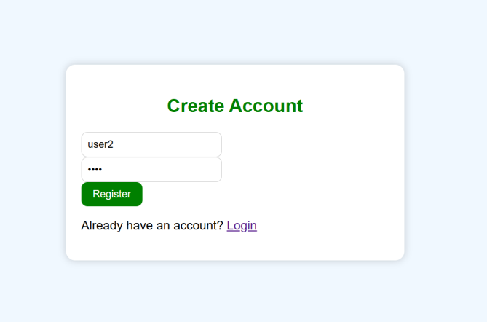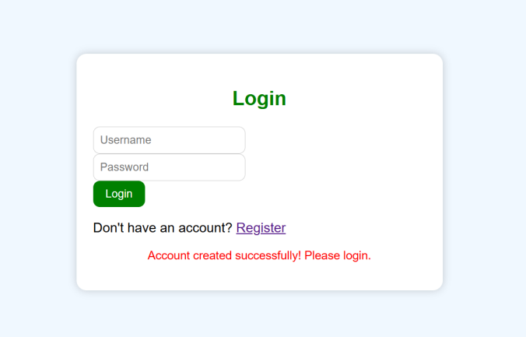

Step 2: Loging into the Chatbot portal using the user credentials (created while registering into the portal)
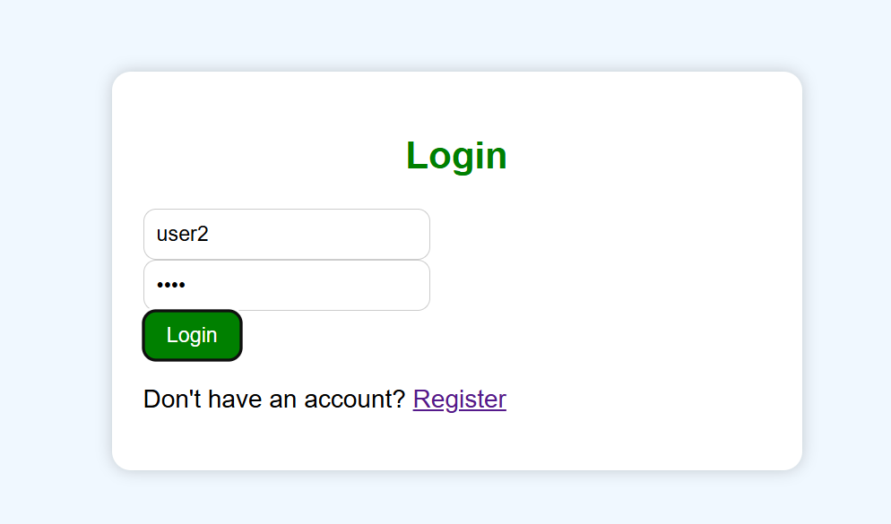
Step 3: Chatbot portal
The chatbot page of Agro Bot Universal serves as the main interaction hub where users can communicate directly with the AI assistant for agricultural support.

Chatbot Page Features
- After login, the user is greeted by name and given an interface to chat with the AI assistant about farming topics.
- The chatbot responds to user queries related to agriculture, such as soil, fertilizer, pests, and harvesting, providing expert guidance and solutions.
- If the AI does not understand the question, it politely asks the user to clarify or to ask about supported topics.
- The interface includes a language selection dropdown, allowing users to interact with the chatbot in English, Tamil, Hindi, Telugu, or Malayalam, supporting accessibility for diverse users.
- The design is visually engaging, with agricultural icons and a background image that sets an inviting, farmer-friendly tone. This intuitive chatbot interface enables users to quickly get answers to farming questions, making agricultural expertise easily accessible to everyone on the platform.
